EDA - Week 3 Deliverable

Team ASK
Westcliff University
DATA200 Applied Statistical Analysis
Professor Regmi
January 25, 2026

EDA - Week 3 Deliverable
Exploratory Data Analysis (EDA) is a necessary step in statistical modeling that helps researchers understand the structure, quality, and characteristics of a dataset before building predictive models. It allows the identification of missing values, outliers, trends, and relationships among variables that may influence model accuracy. In this project, EDA is conducted on the Student Performance dataset to explore how demographic characteristics, study behaviors, and school engagement factors affect academic outcomes. Python libraries such as Pandas, NumPy, Matplotlib, and Seaborn are used for data cleaning, preprocessing, and visualization.
Dataset Overview
The dataset consists of structured student records, where each row represents an individual student and each column corresponds to demographic, behavioral, or academic attributes. Variables include age, gender, school type, parental education, daily study hours, study method, internet access, attendance percentage, travel time, participation in extracurricular activities, subject-wise marks in Math, Science, and English, and overall performance scores and grades. The dataset integrates behavioral and academic factors, making it suitable for statistical analysis and predictive modeling of student performance.
Data Cleaning and Processing
Before we started analyzing the data, we needed to make sure it was clean and ready to use. First, we looked at the dataset to see how it was structured, what kind of information it had, and whether all the columns were in the correct format. This helped us understand what we were working with. Next, we checked for missing values. Sometimes data can have empty cells, and if we don’t handle them, it can affect our results.

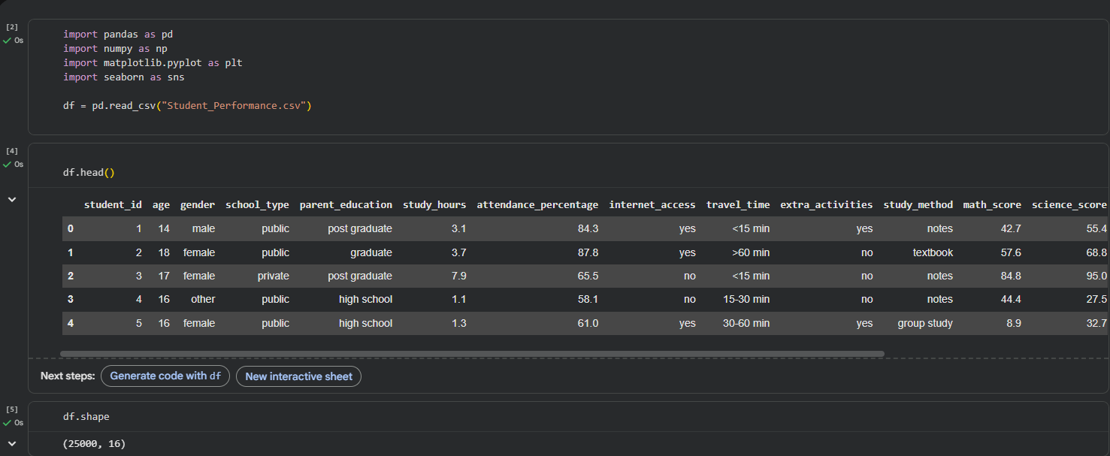
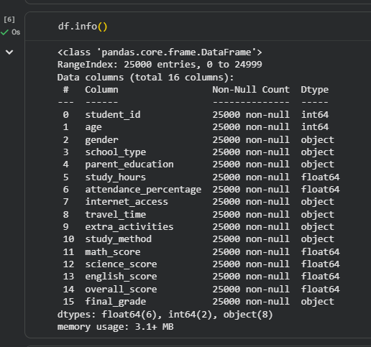
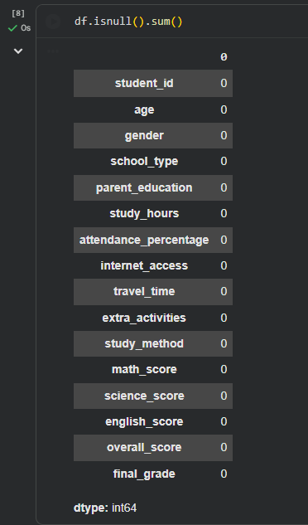
Histogram
A histogram was plotted to examine how student scores are distributed across the dataset. This helps determine whether the data follows a normal distribution and identifies clusters or extreme values.
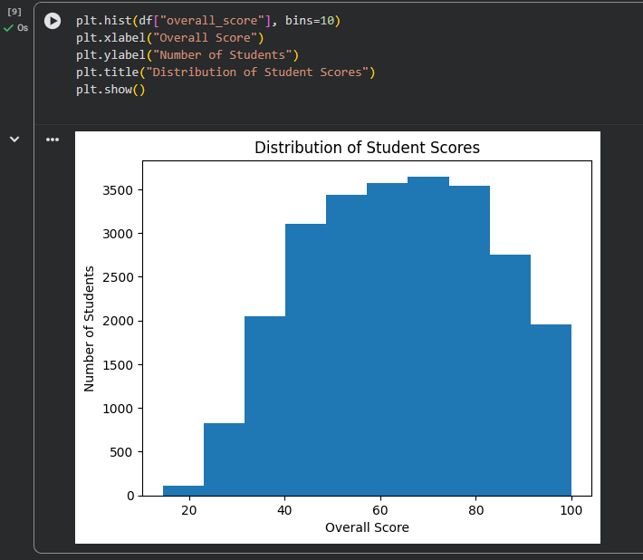
Scatter Plot
A scatter plot was used to analyze the relationship between study time and performance. This helps visually assess correlation between the two variables.
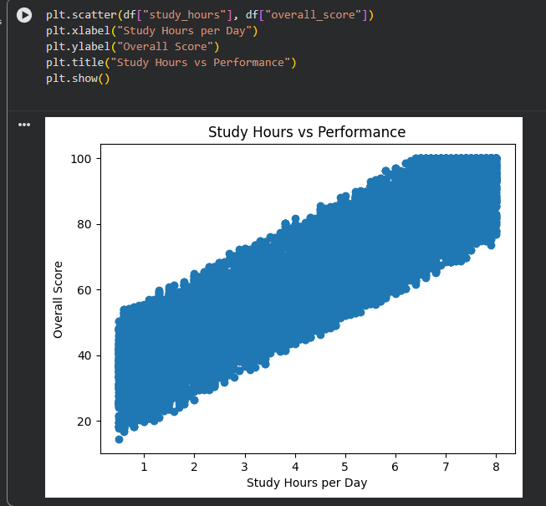
Bar Chart
A bar chart was generated to compare average scores across different parental education levels. This helps analyze the impact of family background on academic success.
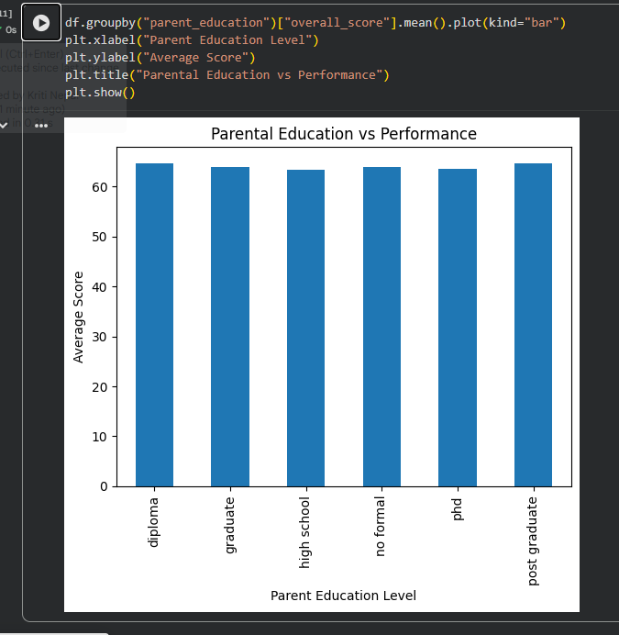

Key Findings
After some EDA, the key findings were:
- Study hours positively influence academic scores
- Higher attendance leads to better performance
- Parental education shows moderate impact
- Most scores follow a normal distribution
- The dataset is clean and suitable for regression modeling
Conclusion
The exploratory data analysis successfully prepared the dataset for predictive modeling by ensuring cleanliness, consistency, and reliability. Data preprocessing steps removed missing values, duplicates, and outliers, while encoding converted categorical variables into usable formats. Visualizations revealed strong relationships between study habits, attendance, and academic outcomes. These findings justify proceeding with statistical modeling techniques such as linear regression or logistic regression in the next stage of the project to predict student performance accurately.

